|  |
| --- |
|  |
| Unit 8: Sequences & Series |
|  |

Our Learning Goals:

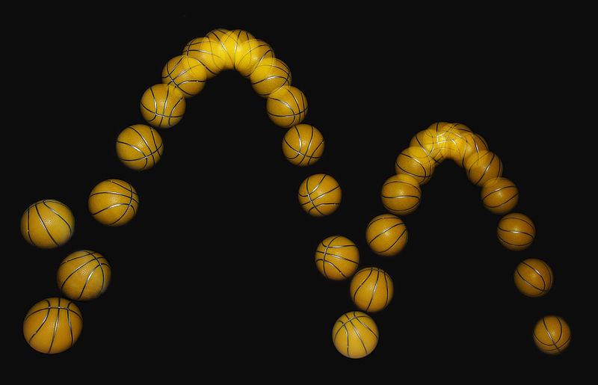

# Sample Problem:

A certain ball has the property that each time it falls from a height $h$ onto a hard, level surface, it rebounds to a height $rh$ where $0<r<1$. Suppose that the ball is dropped from an initial height of $H$ meters. Assuming the ball continues to bounce, find the total distance that it travels.

|  |
| --- |
|  |
| Additional Support:  * Check the teacher web page and Canvas page for notes, activities, and assignments. * Search the topic on the web. We recommend using Khan Academy and CollegeBoard Student Resources. * Attend tutorials. |

**We will:**

* Differentiate between arithmetic and geometric sequences and series.
* Determine and apply various tests for convergence on sequences and series.
* Develop power series to represent other functions.
* Manipulate Taylor and MacLauren series

|  |
| --- |
|  |
| Why do we study this?   * Series can be used to integrate some functions that cannot be integrated by other methods. * Physicists use series in fields such as optics, special relativity, and electromagnetism. * Sequences and series allow us to analyze various phenomena. |
|  |

How we will show what we have learned…

|  |  |
| --- | --- |
| Formative Assessments | Summative Assessments |
| Ongoing formative assessments during lesson and homework activities will help in monitoring learning and providing feedback for students. | * Summative assessments to measure learning at the end of concepts will include teacher-made tests and a district common assessment, which includes multiple choice and free response questions. |